WEALDSTONE FOOTBRIDGE
ASSESSMENT OF CROSSING POINTS
OVER WEST COAST MAIN LINE RAILWAY

Background
The Mayor’s Transport Strategy focuses on creating ‘Healthy Streets’ and the Liveable Neighbourhoods programme has been created to deliver the goal of making walking, cycling and using public transport easier, and to encourage fewer trips by car. Harrow Council has an aspiration to create a Liveable Neighbourhood in Wealdstone.

Wealdstone is a neighbourhood that faces many challenges which negatively impact the liveability of the area. One of these is the severance caused by the West Midland Railway which cuts Wealdstone in half from its northwest to southeast corners and where railway crossings are limited and of very low quality. The area is being dissected into a north-eastern segment and south-western segment. This affects the walkability of the area and causes long detours to use the crossing points. Plan 1 below taken from the liveable neighbourhood bid submitted in 2019 illustrates the severance caused by the West Midland Railway, shown as a red line, and to a lesser extent the A 409, shown as a blue line.

Kodak site
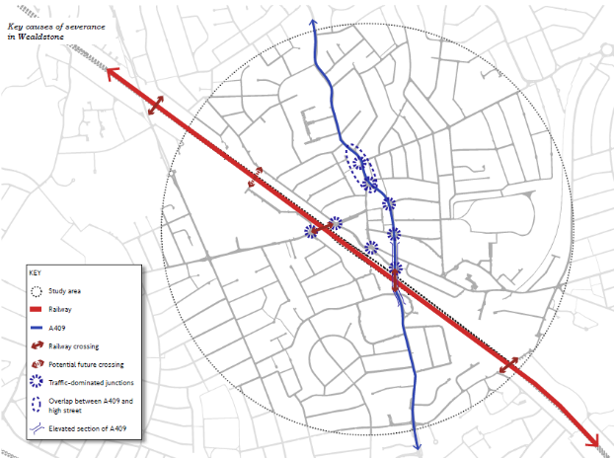
Plan 1

It is proposed to address this severance by improving the four existing crossing points and introducing a new crossing through the Kodak development site, the redevelopment of which will provide new pedestrian routes through this previously private land holding. The four existing crossing points are highlighted in yellow and the proposed new crossing point, utilising the improved access through the redeveloped Kodak site is highlighted in red.

The section of railway between the rail bridge over Headstone Drive and the footbridge over the railway near Courtenay Avenue in the northwest corner of the town has the longest section of railway between crossing points at over one kilometre. A crossing point midway along this section is therefore proposed as shown in the extract from the liveable neighbourhood bid in 2019 below.

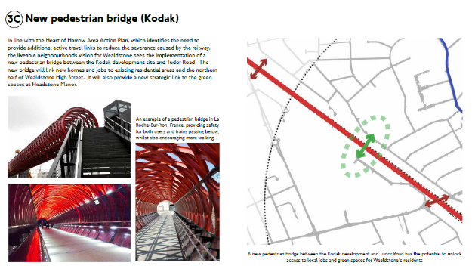

Key destinations and benefits of improved permeability

Plans 2 and 3 shown below indicate all of the key destinations within Wealdstone including the commercial centre, railway station, schools, green spaces and bus services which are all within walking distance of the town centre. By reducing the barrier created by the railway line and improving permeability across it will reduce walking distances to these key destinations and make walking a more attractive option for local residents and businesses. This improved permeability will benefit Wealdstone by reducing congestion and delay on the road transport network and by decreasing the number of motor vehicle journeys and improving the public health of the local population through more active lifestyles and improved physical fitness.

Plans 2 and 3 show the new pedestrian desire line in a thick red line and the existing routes via existing crossing points in red dotted lines.

The main benefits of the new Desire Line for residents are as follows:

- Premises on the eastern side of the railway will gain more direct access to green space at Headstone Manor Park and homes under construction on Kodak development site,
- Homes on the western side of the railway in the Kodak development site and surrounding estates will gain more direct access to schools and religious / cultural centres on the eastern side, the northern end of the commercial centre and a planned strategic north / south cycle route.
- The eastern and western sides of the railway will gain improved and direct access to bus routes on either Harrow View to the west of the railway or the High Street and Locket Road to the east side of the railway.

Temple
Cultural centre
Methodist church
Baptist church
(G)
(H)
(F)
(E)
(D)
(C)
(B)
(A)
Catholic church
The Sacred Heart College
Belmont School
Salvatorian College
Whitefriars School
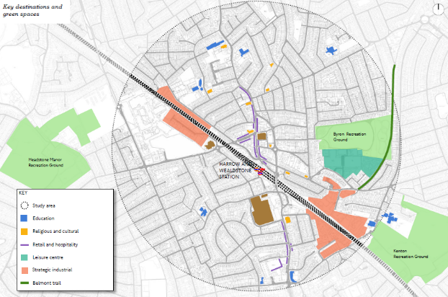
Key destinations and green spaces
Kodak site
Plan 2

(G)
(H)
(F)
(E)
(D)
(C)
(B)
(A)
Courtenay Avenue
Route H14
Locket Road
Route 186
High Street / High Road
Routes 140, 182, 258, 340, 640, N18, N140
Local transport connections
Kodak site
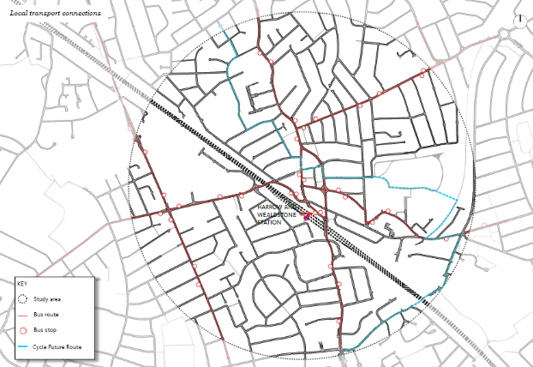
Station Road
Routes 140, 182, 186, 258, 340, 640, N18, N140
Parkside Way
Routes H9 / H10
Harrow View
Route H14
Christchurch Avenue
Routes H9 / H10
Plan 3

The table below sets out walking distances between destinations on either side of the railway using the current crossing points and the proposed new crossing point, clearly demonstrating the benefit a new crossing point will bring to the inhabitants of Wealdstone

Route | Via existing footbridge (Carmelite Road) | Via existing road underpass (Headstone Drive) | Via proposed new footbridge  (through the Kodak site)
(A) Waverley Industrial Park, Hailsham Drive (northern end) to (B) Barratt Way Industrial Estate entrance, Tudor Road | 1,390m | 1,110m | 266m
(C) Kodak east / west sites, Harrow View roundabout to (D) High Street / Spencer Road (clock tower) northern end of commercial centre | 1,630m | 1,540m | 1,080m
(C) Kodak east / west sites, Harrow View roundabout to (E) Wealdstone Baptist Church, High Street | 1,720m | 1,480m | 1,160m
(F) Headstone Manor Park to (G) Whitefriars School entrance | 2,190m | 1,930m | 1,380m
(F) Headstone Manor Park to (H) Belmont School entrance | 3,020m | 2,300m | 2,110m

Potential crossing points

To facilitate improved walking journey times between key destinations the crossing point must be strategically located to connect them effectively and efficiently.

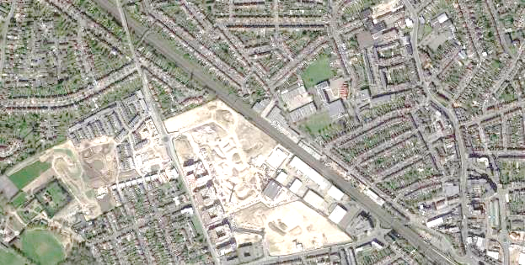
BARRATT WAY INDUSTRIAL SITE
Zone for potential crossing points (approx. 200m long)
400m
400m
KODAK DEVELOPMENT
SITE
Bridge over Headstone Drive
Footbridge connecting Carmelite Road and Courtenay Avenue

Plan 4

Thus the potential crossing point should be situated at the midpoint between the Carmelite Road and Courtenay Avenue footbridge and the Headstone Drive railway bridge and will therefore be along a short section of the railway approximately 200m in length in a zone no closer than 400m to either existing crossing point as shown in Plan 4 above. Any bridge built outside of this area will not deliver the pedestrian route improvements desired.

A survey of this area, and an assessment of the Kodak redevelopment plans have identified four potential crossing points. These potential crossing points need to avoid the overhead line electrification gantries, represented by black dashed lines, on the drawing below, due to the excessive height clearance required. To note, the land on the western side of the railway in the drawing below shows the historic Kodak layout and not the proposed layout of the development.

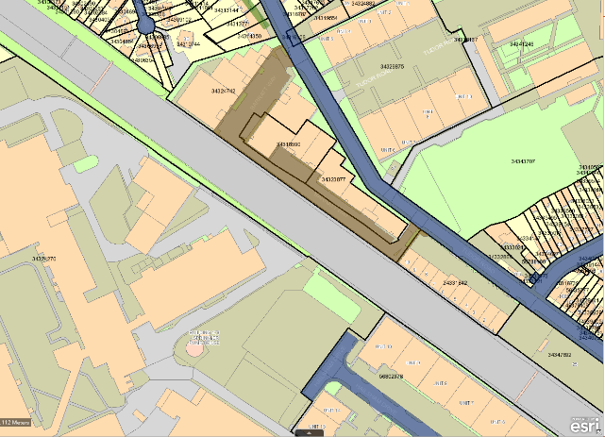
D
C
B
A

Plan 5

An analysis of each of these potential crossing points is set out below. Each crossing point will require the acquisition of land from at least two landowners on either side of the bridge.

Crossing point A

On the southwest side of the railway, the bridge lands within the Kodak development site on a plot which is in the ownership of Big Yellow. This plot is identified for industrial use as a part of the agreed masterplan for the site. The proposed layout of this plot is shown in the plan below.

Crossing point A shown on Plan 6 lands on a proposed service road at the edge of the land boundary with the railway. There is sufficient room to introduce a bridge support, staircase and lift but it will require amendments to the proposed layout of the service road and proposed parking / loading spaces in the development. The line shown in blue represents the access road within the development site that will become public highway. The red dotted lines indicate the pedestrian routes through the industrial estate, along the estate road which is not public highway but would be required to connect the bridge to the public highway. Establishing these rights of way would need to be negotiated with the developer / landowner. The routes are not direct and need to skirt around the proposed buildings.

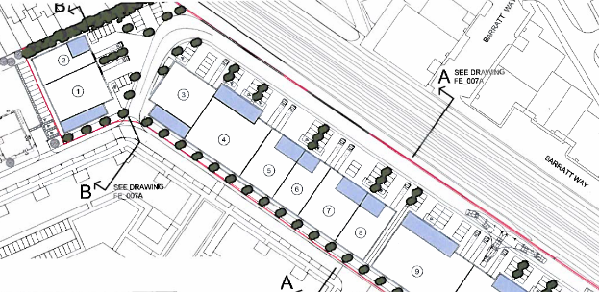
A

Plan 6

On the northeast side of the railway are residential premises in Lynn Court and a private parking area. There is sufficient room to introduce a bridge support, staircase and lift in the parking area but it will reduce the available parking space for residents. This land is not public highway and the bridge will affect two residential land parcels, one across a garden and the other with the parking area. The red dotted line shown on Plan 7 indicates the pedestrian route through the parking area that would be required to connect the bridge to the public highway in Lynn Court. This is an area where there is high demand for on-street and off-street parking and so it is likely that residents would resist any proposals to reduce the amount of car parking because they would be disadvantaged by the loss of parking amenity.
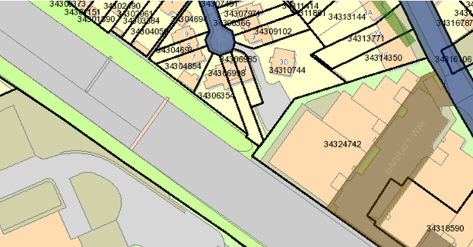
A

Plan 7

Using Lynn Court would require the pedestrians to walk along this road to Carmelite Road to link with Tudor Road. The use of this residential route by pedestrians would be undesirable for local residents due to the intrusion and risk of damage to parked vehicles and conflict between vehicles and pedestrians on the access road. The photos below show the private parking area where the bridge would land and the route required for the right of access to connect to the public highway.

An alternative route to the public highway could be created along the boundary of the Barratt Way Industrial Estate providing a link between Tudor Road and Lynn Court and the bridge. However, the space is too narrow to create a right of way and allow sufficient access to the rear of the buildings in the Barratt Way Industrial Estate for maintenance.

The establishment of a pedestrian bridge in this location will require negotiation with the three landowners.

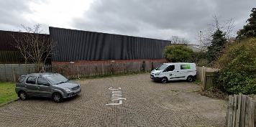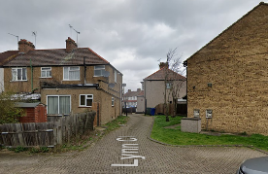

Private car park area and access road at back of nos.3 - 6 Lynn Close

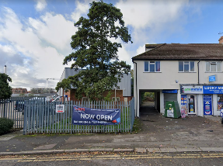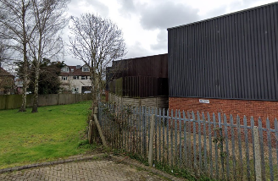

Boundary of Barratt Way Industrial Estate from Tudor Road and Lynn Court

Crossing point B

On the southwest side the bridge lands within the Kodak development site on a plot which is in the ownership of Big Yellow. This plot is identified for industrial use as a part of the agreed masterplan for the site. The proposed layout of this plot is shown in Plan 8 below.

Crossing point B would land on a proposed service road at the edge of the land boundary with the railway. There is sufficient room to introduce a bridge support, staircase and lift but it will require amendments to the proposed service road and proposed parking / loading spaces in the development. The line shown in blue represents the access road within the development site that is proposed to become public highway. The red dotted lines indicate the pedestrian routes through the development that would be required to connect the bridge to the public highway. Establishing these rights of way would also need to be negotiated with the developer / landowner. The route is direct and connects from the public highway, along a path in between buildings, across the estate road, potentially requiring a pedestrian crossing to the bridge.

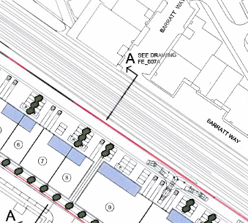
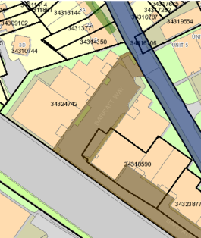
B
B
Plan 8

On the northeast side of the railway is the Barratt Way Industrial Estate (see plan 8 on right hand side above) and the bridge lands on entry roadway to the estate as it turns through 90 degrees to run parallel to the railway line. There is sufficient room here to introduce a bridge support, staircase and lift in the industrial state access road and parking area but it will reduce the available parking space for businesses. The bridge would need to pass over the internal access road at the boundary with the railway before landing next to the building. The red dotted line indicates the pedestrian route through the parking area that would be required to connect the bridge to the public highway in Tudor Road. This is a direct route but will require out of hours access through the gate which secures the industrial estate. This proposal would have a detrimental impact on businesses in the industrial estate and could affect up to 20 car parking spaces (see photo below). The access road is wide and there may be scope to amend the parking layout around a pedestrian route. However, the use of this route by pedestrians would be undesirable to businesses due to the intrusion and the risk of damage to parked vehicles and the requirement for 24 hour access to the bridge. The bridge and pedestrian route would also cut the site in half and affect any future development plans for the site by introducing a site constraint.

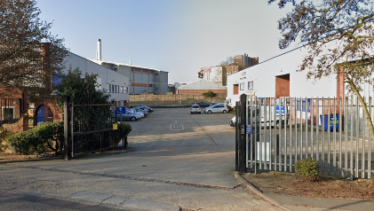

Barratt Way Industrial Estate – entrance to Business Park on Tudor Road

This route will require negotiation with two landowners on either side for the bridge in order to formalise landing points and to make connections to the public highway. It may also require negotiation with the occupiers who may have allocated car parking spaces.

Crossing point C

On the southwest side the bridge lands within the Kodak development site on a plot which is in the ownership of Big Yellow. This plot is identified for industrial use as a part of the agreed masterplan for the site. The proposed layout of this plot is shown in Plan 9 below.

Crossing point C shown on the plan lands on a proposed service road at the edge of the land boundary with the railway and close to the public highway. There is sufficient room to introduce a bridge support, staircase and lift but it will require amendments to the proposed service road and proposed parking / loading spaces in the development. The area shaded in blue represents the extent of the public highway (Hailsham Drive). The red dotted lines indicate the pedestrian route through the development that would be required to connect the bridge to the public highway. Establishing this right of way would also need to be negotiated with the developer / landowner and the short route adopted as public highway or where negotiations fail compulsorily acquired and provided to the public as public highway. The route is short and direct and would connect the bridge directly with the public highway.

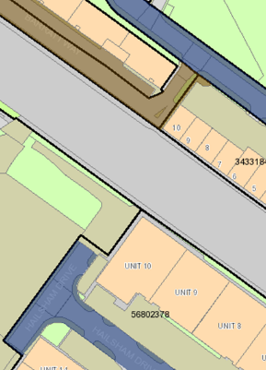
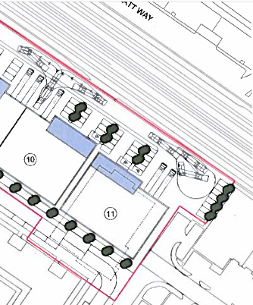
C
C
Plan 9

On the northeast side of the railway is the Barratt Way Industrial Estate (see plan 9 on right hand side above). There is sufficient room to introduce a bridge support, staircase and lift in the industrial estate exit road. The bridge would need to pass over the internal estate exit road at the boundary with the railway before landing next to the building. The red dotted line indicates the pedestrian route through the site area that would be required to connect the bridge to the public highway in Tudor Road which is a short and direct route.

This proposal would have a minimal impact on businesses in the industrial estate as this area provides the exit road from the site and parking is restricted. The access road is wide enough to include the bridge and an exit route from the industrial estate. The use of this route by pedestrians would have little impact on businesses as there are no business frontages facing the bridge as the bridge lands to the side of the building. The bridge and pedestrian route are located at the very end of the site and will be less likely to affect any future development plans for the site. Furthermore, if this short piece of estate road was adopted as highway there would be no need for a permissive licence for the public to cross private land and the Estate’s security gates could be moved to directly before the 90 degree turn away from the railway so that the security of the industrial estate was not compromised and vehicles would continue to exit straight onto the highway.

The photos below show the areas where the bridge would land and the route required for the public to access the public highway Tudor Road, which could be adopted with the landowner’s consent. The black gates pictured would be rotated through 90 degrees and re-positioned at the end of the estate road which runs parallel with the railway.

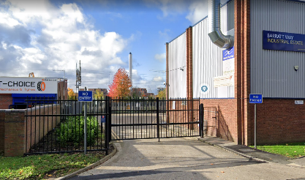

Barratt Way Industrial Estate – exit from Business Park on Tudor Road

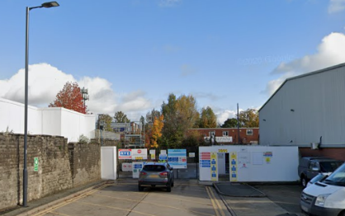

Hailsham Drive turning head

This location requires negotiations with the landowners on either side of the railway in order to formalise landing points and with the industrial estate who own a slither of land to make connections to the public highway.

Crossing point D

On the southwest side the bridge lands within the Kodak development site on a plot which is in the ownership of Big Yellow. This plot is identified for industrial use as a part of the agreed masterplan for the site. The proposed layout of this plot is shown in plan 10 below.

Crossing point D shown on the plan lands on a proposed service road at the edge of the land boundary with the railway and close to the public highway. There is sufficient room to introduce a bridge support, staircase and lift but it will require amendments to the proposed service road and proposed parking / loading spaces in the development. The area shaded in blue represents the extent of the public highway (Hailsham Drive). The red dotted lines indicate the pedestrian route through the development that would be required to connect the bridge to the public highway. Establishing these rights of way would also need to be negotiated with the developer / landowner and the short route adopted as public highway or where negotiations fail, compulsorily acquired and provide to the public as public highway. The route is short and direct and would connect the bridge directly with the public highway
D
D
Plan 10

On the northwest side of the railway is the Tudor Enterprise Park (see plan 10 on right hand side above). This option would require the purchase and demolition of two units (Units 9 & 10) within the development and further public realm related works to introduce a bridge support, staircase and lift in the industrial estate land. The red dotted line indicates the pedestrian route through the site area that would be required to connect the bridge to the public highway in Tudor Road which is a short and direct route and could be adopted as public highway. This proposal would have a significant impact on employment in the Borough as it would remove two industrial units from the Enterprise Park, thereby reducing the availability of employment premises which is in contravention with local planning policy and the London Plan. Furthermore, the resulting demolition would affect the investment value of the estate for which the freeholder would need to be compensated and the occupying businesses will also require compensation in line with statutes. The bridge and pedestrian route are located at the very end of the site and will not cause any severance of the site in terms of any future development plans, but it would sterilise a piece of land which was previously providing employment opportunities.

The use of this route by pedestrians after the acquisition of land would have little impact on businesses as they would be separated from the bridge and pedestrian route. The photos below show the areas where the bridge would land and the route required for the right of access to connect to the public highway.

This location requires negotiations with landowners on both sides of the railway in order to formalise landing points and to make connections to the public highway Additionally surrender of the leases of the two units will need to be agreed with the occupiers.

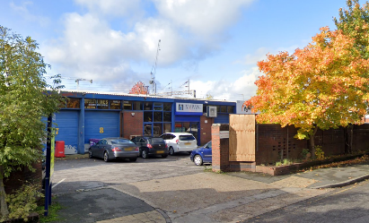

Tudor Enterprise Park – exit from Business Park on Tudor Road

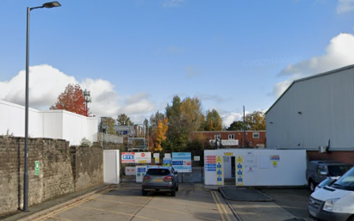

Hailsham Drive turning head

Summary of options

The table below summarises the main factors for the four options described in this report as follows:

Option | A | B | C | D
Length of pedestrian route between areas of existing public highway | 225m – 255m | 100m | 100m | 85m
Residential land parcels affected | 2 | 0 | 0 | 0
Business land parcels affected | 1 | 3 | 2 | 3
Total number of land parcels affected | 3 | 3 | 2 | 3
Land acquisition required | Yes | Yes | Yes | Yes
Demolition of buildings required | No | No | No | Yes
Existing private parking areas affected | Yes | Yes | No | Yes
Impact on residents | High | - | - | -
Impact on businesses | High | High | Moderate | Very High
Land / legal cost implication | High | Moderate | Moderate | Very High
Route safety | Poor | Poor | Good | Good

The advantages and disadvantages of the options are summarised below:

Option | Advantages | Disadvantages
A | - No demolition of buildings required  - No impact on businesses  - Kodak site development plans do not obstruct planned bridge | - Connecting route between the highway is not direct and is the longest in length  - Much of the route is not along adopted/public highway  - Would cause nuisance and disturbance to residents  - Loss of parking amenity for residents
B | - Connecting route between the highway is direct on both sides.  - No demolition of buildings required  - No physical impact on access / egress to Barratt Way Industrial Estate or to business premises  - Kodak site development plans do not obstruct planned bridge | - Would cause nuisance and disruption to businesses in Barratt Way Industrial Estate  - Would affect parking arrangements in Barratt way Industrial Estate  - Would detrimentally impact on marketability of the Barratt Way site in the future due to position of structure and severance of site  - Would affect the security of Barratt Way Industrial Estate as access to the bridge would be required 24 hours a day
C | - Connecting route between the highway is direct and short on both sides and no right of ways are required if land is adopted as public highway  - No demolition of buildings required  - No impact on access / egress to Barratt Way Industrial Estate  - Kodak site development plans do not obstruct planned bridge  - No impact on parking arrangements in Barratt Way Industrial Estate | - Staircase to bridge is close to end building in Barratt Way Industrial Estate, potential impacting on maintenance and nuisance from public
D | - Connecting route between the highway is direct and short on both sides and no right of ways are required if land is adopted as public highway  - Kodak site development plans do not obstruct planned bridge | - Demolition of two buildings required on Tudor Enterprise Park  - Detrimental impact on local employment and businesses  - Detrimental impact marketability of the Tudor Enterprise Park site in the future  - Impact on parking arrangements in Tudor Enterprise Park site.  - Impact on access / egress to Tudor Enterprise Park site.

Conclusion and Recommendation

Option A has been discounted because the pedestrian routes are not sufficiently direct and are significantly longer than the other options on both sides of the railway. Furthermore, much of the route is outside the public highway on private land and could provide safety concerns preventing pedestrians using the bridge at night and in the winter. The routes on the northeast side are also likely to cause nuisance to residents and affect parking amenity. The Kodak site development plans would need to be amended to accommodate the bridge structure.

Option B provides a short and direct route but there is a high impact on the operation of the businesses in the Barratt Way Industrial Estate. Car parking areas are affected as well as the frontages to the business units closest to the route and 24 hour access will need to be given to the bridge. The route also severs the site in two which will be unattractive for future development of the site. The Kodak site development plans would need to be amended to accommodate the bridge structure.

Option C provides a short and direct route which has a moderate impact on the exit road of the Barratt Way Industrial Estate. No parking on the site is affected and the crossing point is very close to one end of the site and unlikely to affect any future development plans. The bridge would be able to land on adopted highway on both sides assuming small areas of land are adopted. The Kodak site development plans would need to be amended to accommodate the bridge structure.

Option D provides the shortest and most direct route but has a significant impact on the Tudor Enterprise Park requiring the demolition of two buildings and the acquisition of this element of the site. This will involve very high costs of compensation and will significantly affect local businesses. The bridge would be able to land on adopted highway on both sides assuming small areas of land are adopted. The Kodak site development plans would need to be amended to accommodate the bridge structure.

On balance Option C provides the best combination of directness, the least impact on residents and businesses and a potentially lower level of cost and so Option C is the preferred and recommended option.

David Eaglesham

Head of Traffic, Highways & Asset Management

